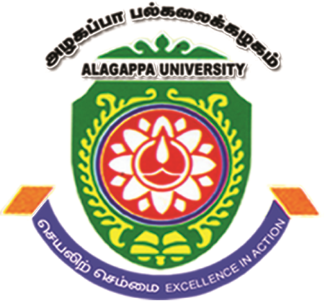
ALAGAPPA UNIVERSITY
(A State University Accredited with ‘A+’ Grade by NAAC (CGPA: 3.64) in the Third Cycle and
Graded as Category - I by MoE-UGC, 2020: The World University Rank: 501-600, QS ASIA Rank: 220, NIRF Rank: 28)
KARAIKUDI – 630 004, TAMIL NADU, INDIA
DEPARTMENT OF BIOINFORMATICS
(UGC-INNO, DST - FIST-PURSE, DBT-BIC and RUSA 2.0 Sponsored Department)

2nd International Conference cum Workshop on
“Recent Trends in Structural Bioinformatics and Computer Aided Drug Design” (ICSBCADD’2022)

21st – 25th November 2022

REGISTRATION FORM
(To be filled in block letters)

Name: ______________________________________________________________________________________________________
Gender: ________________________ Designation: _________________________________________________
Institutional Affiliation with Postal Address: __________________________________________________________
__________________________________________________
Tele/Mobile: ____________________________ Email: __________________________________________________________
Participant

Poster

Presenting/Attending:

Title of the Paper: _______________________________________________________________________________________
____________________________________________________________________________________________________________
____________________________________________________________________________________________________________
Accommodation needed:

No

Yes

(Last Date: on or before October 10th, 2022)
Particulars of Fee:
Amount Rs. ___________________________ Transaction ID/DD No: ________________________________________
Date: ___________________________ Name of the Bank: __________________________________________________

Applicant Signature Head of the Department/Research Supervisor

Note:
- The participants are requested to send the duly filed registration form along with the registration fee on or before October 10th, 2022. Registration fee is to be remitted in the Indian Bank SB A/c: 7262932047 (Branch: Alagappa College Campus, IFSC Code: IDIB000A008). The proof of remittance is to be attached during registration.
- Demand draft drawn in favor of 'THE CONVENOR ICSBCADD-22' payable at Karaikudi is also acceptable.
- For Accommodation, enquiry contact The Convenor at dbiicsbcadd@gmail.com

